Chapter 10
Externalities

MULTIPLE CHOICE
1. Which of the following is the best statement about markets?
a. Markets are usually a good way to organize economic activity.
b. Markets are generally inferior to central planning as a way to organize economic activity.
c. Markets fail and are therefore not an acceptable way to organize economic activity.
d. Markets are a good way to organize economic activity in developed nations, but not in less-developed nations.
ANS: A Markets are usually a good way to organize economic activity.
DIF: 1 SECTION: 0 TYPE: M
2. In a market economy, economic activity is guided by
a. the government.
b. businesses.
c. central planners.
d. prices.
ANS: D prices.
DIF: 1 SECTION: 0 TYPE: M
3. Because decisions in a market economy are guided by individual self-interest, there is
a. a strong need for government intervention in the market.
b. less efficiency in market economies than in command economies.
c. nevertheless the ability to achieve desirable economic well-being for society as a whole.
d. more need for a strong legal system to control individual greed.
ANS: C nevertheless the ability to achieve desirable economic well-being for society as a whole.
DIF: 1 SECTION: 0 TYPE: M
4. If there are no externalities, the "invisible hand" leads a market to maximize
a. producer profit from that market.
b. total benefit to society from that market.
c. both equity and efficiency in that market.
d. output of goods or services in that market.
ANS: B total benefit to society from that market.
DIF: 2 SECTION: 0 TYPE: M
5. In the absence of externalities the invisible hand of the marketplace
a. leads to a market outcome that maximizes total benefit to society.
b. is unable to resolve inherent inefficiencies in the market system.
c. induces people to act in a manner inconsistent with self interest.
d. increases the transactions cost of contracting between parties to an exchange.
ANS: A leads to a market outcome that maximizes total benefit to society.DIF:
DIF: 1 SECTION: 0 TYPE: M
6. One advantage market economies have over other types of economies is that market economies
a. provide an equal distribution of goods and services to consumers.
b. establish government economic control.
c. solve the problem of scarcity.
d. are more efficient.
ANS: D are more efficient.
DIF: 1 SECTION: 0 TYPE: M
7. The term market failure refers to
a. a situation in which the market, on its own, fails to allocate resources efficiently.
b. an unsuccessful advertising campaign which reduces demand.
c. a situation in which competition among firms becomes ruthless.
d. a firm which is forced out of business because of losses.
ANS: A a situation in which the market, on its own, fails to allocate resources efficiently.
DIF: 1 SECTION: 0 TYPE: M
8. Market failure can be caused by
a. foreign competition.
b. externalities.
c. low consumer demand.
d. scarcity.
ANS: B externalities.
DIF: 1 SECTION: 0 TYPE: M
9. An externality is the impact of
a. society's decisions on the well-being of society.
b. a person's actions on that person's well-being.
c. one person's actions on the well-being of a bystander.
d. society's decisions on the well-being of one person in the society.
ANS: C one person's actions on the well-being of a bystander.
DIF: 1 SECTION: 0 TYPE: M
10. An externality exists when
a. the government intercedes in the operation of private markets by forcing the market to adjust to the balance of supply and demand.
b. markets are not able to reach equilibrium.
c. a firm sells its product in a foreign market.
d. a person engages in an activity that influences the well-being of a bystander and yet neither pays nor receives payment for that effect.
ANS: D a person engages in an activity that influences the well-being of a bystander and yet neither pays nor receives payment for that effect.
DIF: 2 SECTION: 0 TYPE: M
11. Externalities cause markets to
a. fail to allocate resources efficiently.
b. cause price to be different than the equilibrium price.
c. benefit producers at the expense of consumers.
d. cause markets to operate more equitably.
ANS: A fail to allocate resources efficiently.
DIF: 2 SECTION: 0 TYPE: M
12. When externalities are present in a market
a. the established equilibrium maximizes the total benefit to society as a whole.
b. market participants lose some market benefits to bystanders.
c. both equity and efficiency are maximized.
d. the market fails to allocate resources efficiently.
ANS: D the market fails to allocate resources efficiently.
DIF: 2 SECTION: 0 TYPE: M
13. Private markets fail to account for externalities because
a. externalities don't occur in private markets.
b. sellers include costs associated with externalities in the price of their product.
c. decisionmakers in the market fail to take account of the external effects of their behavior.
d. the government can easily correct any adverse effect on the market that externalities may cause.
ANS: C decisionmakers in the market fail to take account of the external effects of their behavior.
DIF: 2 SECTION: 1 TYPE: M
14. If an externality is present in a market, economic efficiency may be enhanced by
a. increased competition.
b. weakening property rights.
c. better informed market participants.
d. government intervention.
ANS: D government intervention.
DIF: 1 SECTION: 1 TYPE: M
15. Negative externalities occur when one person's actions
a. cause another person to lose money in a stock market transaction.
b. cause his or her employer to lose business.
c. reveal his or her preference for foreign-produced goods.
d. adversely affect the well-being of a bystander who is not party to the action.
ANS: D adversely affect the well-being of a bystander who is not party to the action.
DIF: 2 SECTION: INTRO TYPE: M
16. A negative externality
a. is an adverse impact on a bystander.
b. causes the product in a market to be under-produced.
c. is an adverse impact on market participants.
d. is present in markets in which the good or service is undesirable for society.
ANS: A is an adverse impact on a bystander.
DIF: 1 SECTION: 1 TYPE: M
17. Which of the following illustrates the concept of a negative externality?
a. A college professor plays a vigorous game of racquet ball with the racquet he recently purchased.
b. A flood wipes out a farmer's entire corn crop.
c. A college student plays his new stereo system at 2:00 a.m.
d. A janitor eats a Big Mac during his lunch break.
ANS: C A college student plays his new stereo system at 2:00 a.m.
DIF: 2 SECTION: 1 TYPE: M
18. When negative externalities are present in a market
a. producers will be affected, but not consumers.
b. overproduction will occur.
c. demand will be too high.
d. the market will still maximize total benefits.
ANS: B overproduction will occur.
DIF: 2 SECTION: 1 TYPE: M
19. Which of the following would NOT be considered a negative externality?
a. Smelter, Inc. creates steel and pollution in Anytown, U.S.A.
b. Your friend buys a new puppy that barks every night.
c. You have an adverse reaction to a medication your doctor prescribed for you.
d. Your neighbor buys the most powerful stereo money can buy for his patio.
ANS: C You have an adverse reaction to a medication your doctor prescribed for you.
DIF: 3 SECTION: 1 TYPE: M
20. One of the Ten Principles of Economics is that "markets are usually a good way to organize market behavior." Use of the word "usually" does NOT reflect the fact that
a. some markets produce negative externalities.
b. the invisible hand of the marketplace does not always lead buyers and sellers to maximize total benefit to society.
c. some markets are characterized by market failure.
d. other types of economies are more efficient than market economies.
ANS: D other types of economies are more efficient than market economies.
DIF: 2 SECTION: 0 TYPE: M
21. When externalities exist, buyers and sellers
a. neglect the external effects of their actions but the market equilibrium is still efficient.
b. do not neglect the external effects of their actions and the market equilibrium is efficient.
c. neglect the external effects of their actions and the market equilibrium is not efficient.
d. do not neglect the external effects of their actions and the market equilibrium is not efficient.
ANS: C neglect the external effects of their actions and the market equilibrium is not efficient.
DIF: 2 SECTION: 0 TYPE: M
22. Dioxin emission that results from the production of paper is a good example of a negative externality because
a. self-interested paper firms are generally unaware of environmental regulations.
b. there are fines for producing too much dioxin.
c. self-interested paper producers will not consider the full cost of the dioxin pollution they create.
d. toxic emissions are the only form of an externality.
ANS: C self-interested paper producers will not consider the full cost of the dioxin pollution they create.
DIF: 2 SECTION: 0 TYPE: M
23. If a paper manufacturer does NOT bear the entire cost of the dioxin it emits it will
a. emit lower levels of dioxin than is socially efficient.
b. emit higher levels of dioxin than is socially efficient.
c. emit an acceptable level of dioxin.
d. not emit any dioxin in an attempt to avoid paying the entire cost.
ANS: B emit higher levels of dioxin than is socially efficient.
DIF: 2 SECTION: 1 TYPE: M
24. When the government intervenes in markets with externalities it does so to
a. increase production when negative externalities are present.
b. protect interests of bystanders.
c. make certain all benefits are received by market participants.
d. better coordinate the action of buyers and sellers.
ANS: B protect the interests of bystanders.
DIF: 2 SECTION: 1 TYPE: M
25. Policymakers have chosen to solve the problem of too much car exhaust pollution by
a. setting emission standards and limiting driving by commuters.
b. setting emission standards and taxing gasoline.
c. taxing car producers and limiting driving by commuters.
d. taxing gasoline and taxing car producers.
ANS: B setting emission standards and taxing gasoline.
DIF: 2 SECTION: 1 TYPE: M
26. Since restored historic buildings convey a positive externality, local governments may choose to
a. provide tax breaks to owners who restore them.
b. restrict the destruction of historic buildings.
c. increase property taxes in historic areas.
d. All of the above are correct.
e. Both a and b are correct.
ANS: E Both a and b are correct.
DIF: 2 SECTION: 1 TYPE: M
27. Dog owners do not bear the full cost of the noise their barking dogs create and, therefore, tend to take too few precautions to prevent their dogs from barking. Local governments address this problem by
a. making it illegal to "disturb the peace."
b. having a well-funded animal control department.
c. subsidizing local animal shelters.
d. encouraging people to buy cats.
ANS: A making it illegal to "disturb the peace."
DIF: 2 SECTION: INTRO TYPE: M
28. Local governments address the problem of barking dogs by imposing
a. leash laws.
b. dog registration.
c. disturbing the peace laws.
d. All of the above are correct.
ANS: C disturbing the peace laws.
DIF: 2 SECTION: 1 TYPE: M
29. If a sawmill creates too much noise for local residents
a. it will be up to the residents to either adapt or move.
b. a sense of social responsibility will cause owners of the mill to reduce noise levels.
c. the government can raise economic well-being through noise-control regulations.
d. the government can raise economic well-being by providing free hearing screening for residents who live closest to the sawmill.
ANS: C the government can raise economic well-being through noise-control regulations.
DIF: 2 SECTION: 1 TYPE: M
30. Too few resources are generally devoted to research in new technologies in developing countries because
a. new technologies cannot be patented.
b. government research grants are not easily obtainable.
c. negative externalities are created from some research.
d. inventors cannot capture the full benefits of their inventions.
ANS: D inventors cannot capture the full benefits of their inventions.
DIF: 2 SECTION: 1 TYPE: M
31. Research into new technologies
a. provides positive externalities because it creates knowledge others can use.
b. results in negative externalities because government funding for research causes less government spending in other areas.
c. causes too many resources to be used for the small benefits received by society.
d. should only be funded by the corporations which will receive the profits from the research.
ANS: A provides positive externalities because it creates knowledge others can use.
DIF: 2 SECTION: 1 TYPE: M
32. A positive externality
a. causes the product to be overproduced.
b. provides an additional benefit to market participants.
c. benefits consumers because it results in a lower equilibrium price.
d. is a benefit to a market bystander.
ANS: D is a benefit to a market bystander.
DIF: 1 SECTION: 1 TYPE: M
33. If education produces positive externalities we would expect
a. government to tax education.
b. government to subsidize education.
c. people to realize the benefits and therefore cause demand for education to increase.
d. colleges to relax admission requirements.
ANS: B government to subsidize education.
DIF: 2 SECTION: 1 TYPE: M
34. When externalities are present in a market, the well-being of market participants
a. are directly affected and market bystanders are indirectly affected.
b. and market bystanders are both directly affected.
c. and market bystanders are both indirectly affected.
d. are indirectly affected and market bystanders are directly affected.
ANS: A are directly affected and market bystanders are indirectly affected.
DIF: 3 SECTION: 1 TYPE: M
35. Which of the following statements about a well-maintained yard best conveys the general nature of the externalities?
a. A maintained yard conveys a positive externality because it increases the home's market value.
b. A maintained yard conveys a negative externality because it increases the property tax liability of the owner.
c. A maintained yard conveys a negative externality because it makes other property owners in the neighborhood feel like their homes are less valuable.
d. A maintained yard conveys a positive externality because it increases the value of adjacent properties in the neighborhood.
ANS: D A maintained yard conveys a positive externality because it increases the value of adjacent properties in the neighborhood.
DIF: 2 SECTION: INTRO TYPE: M
36. Hikers frequently claim that livestock grazing in Wilderness Recreation Areas reduces the satisfaction of their recreational hiking experience. An explanation would be that
a. hikers don't eat beef.
b. grazing cows create negative externalities which make hiking less pleasant.
c. ranchers are insensitive to the recreational use of public lands.
d. cattle should not be allowed to graze on public property.
ANS: B grazing cows create negative externalities which make hiking less pleasant.
DIF: 2 SECTION: INTRO TYPE: M
37. The impact of one person's actions on the well-being of a bystander is called
a. an economic dilemma.
b. deadweight loss.
c. the third-party problem.
d. an externality.
ANS: D an externality.
DIF: 1 SECTION: INTRO TYPE: M
38. An externality
a. is characterized as a form of market failure.
b. causes markets to allocate resources efficiently.
c. strengthens the role of the invisible hand in the marketplace.
d. requires the producer to compensate society.
ANS: A is characterized as a form of market failure.
DIF: 1 SECTION: INTRO TYPE: M
39. Which of the following is an example of a positive externality?
a. A college student buys a new car when she graduates.
b. The mayor of a small town plants flowers in the city park.
c. Local high school teachers have pizza delivered every Friday for lunch.
d. An avid fisherman buys new fishing gear for his next fishing trip.
ANS: B The mayor of a small town plants flowers in the city park.
DIF: 2 SECTION: 1 TYPE: M
40. The demand curve for a product reflects the
a. value of the product to consumers.
b. cost of the product to consumers.
c. quantity consumers are able to purchase.
d. price the product will sell for in the market.
ANS: A value of the product to consumers.
DIF: 1 SECTION: 1 TYPE: M
41. The height of the demand curve shows
a. how much each buyer in the market is willing to pay.
b. the willingness to pay of the marginal buyer.
c. the maximum price all buyers will pay for a product.
d. the lowest price buyers will pay for a product.
ANS: B the willingness to pay of the marginal buyer.
DIF: 2 SECTION: 1 TYPE: M
42. When a beekeeper places his hives of bees in an orchard so that the bees can gather nectar to produce honey, the bees pollinate the orchard, which increases the yield of fruit. This benefits
a. only the beekeeper.
b. the beekeeper, but creates a negative externality because the bees are a hazard to the orchard owner.
c. only the owner of the orchard.
d. both the beekeeper and the orchard owner.
ANS: D both the beekeeper and the orchard owner.
DIF: 2 SECTION: 1 TYPE: M
43. At any given quantity, the willingness to pay in the market for automobile fuel is reflected in the
a. value to the consumer of the last unit of automobile fuel bought.
b. height of the supply curve at each quantity.
c. value to the producer of the last unit of automobile fuel sold.
d. total quantity of automobile fuel exchanged in the market.
ANS: A value to the consumer of the last unit of automobile fuel bought.
DIF: 3 SECTION: 1 TYPE: M
44. The supply curve for a product reflects the
a. value of the product to suppliers.
b. quantity buyers will ultimately purchase of the product.
c. cost to sellers of producing the product.
d. seller's profit of producing the product.
ANS: C cost to sellers of producing the product.
DIF: 2 SECTION: 1 TYPE: M
45. The height of the supply curve shows the
a. maximum cost a seller will pay to produce a product.
b. price a seller can expect to receive for a certain quantity of a product.
c. maximum amount buyers are willing to pay for a product.
d. cost to the producer of the last unit sold.
ANS: D cost to the producer of the last unit sold.
DIF: 2 SECTION: 1 TYPE: M
46. At any given quantity, the height of the supply curve for pliers shows the
a. willingness to pay of the marginal supplier.
b. willingness to pay of the marginal buyer.
c. cost of the marginal buyer.
d. cost of the marginal seller.
ANS: D cost of the marginal seller.
DIF: 2 SECTION: 1 TYPE: M
47. The height of the supply curve at any given quantity of coal shows the
a. value to the consumer of the last unit of coal bought.
b. consumer's willingness to pay for coal at each quantity.
c. cost to the producer of the last unit of coal sold.
d. total quantity of coal exchanged in the market.
ANS: C cost to the producer of the last unit of coal sold.
DIF: 2 SECTION: 1 TYPE: M
48. Without government intervention, the market equilibrium for oranges will
a. maximize total surplus in the market.
b. be both efficient and equitable.
c. not adjust, even if demand or supply changes.
d. not allocate resources efficiently.
ANS: A maximize total surplus in the market.
DIF: 2 SECTION: 1 TYPE: M
49. When a negative externality exists in a market the cost to producers
a. is greater than the cost to society.
b. will be the same as the cost to society.
c. will be less than the cost to society.
d. and society will be different regardless of whether an externality is present.
ANS: C will be less than the cost to society.
DIF: 3 SECTION: 1 TYPE: M
50. When negative externalities are present in a market
a. private costs will be greater than social costs.
b. social costs will be greater than private costs.
c. government regulation to resolve the problem is always necessary.
d. the market will not be able to reach any equilibrium situation.
ANS: B social costs will be greater than private costs.
DIF: 2 SECTION: 1 TYPE: M

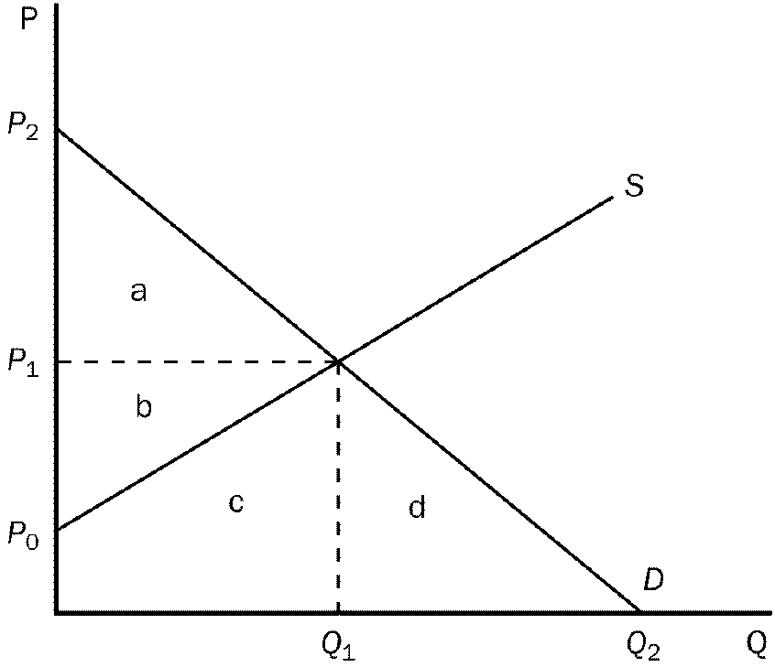
Figure 10-1
51. Refer to Figure 10-1. Producer and consumer surplus at the point of market efficiency is represented by area(s)
a. a + d.
b. b + c
c. c + d
d. a + b
ANS: D a + b
DIF: 2 SECTION: 1 TYPE: M
52. Refer to Figure 10-1. Total surplus would be maximized at what price and quantity combination?
a. P₁and Q₁.
b. P₂ and 0.
c. P₀ and Q₂.
d. P₀ and Q₁.
ANS: A P₁and Q₁
DIF: 1 SECTION: 1 TYPE: M
53. Since air pollution creates a negative externality,
a. welfare will be enhanced when some, but not all air pollution is eliminated.
b. social welfare is optimal when all air pollution is eliminated.
c. governments should encourage all private firms to consider only private costs.
d. the free market result maximizes social welfare.
ANS: A welfare will be enhanced when some, but not all air pollution is eliminated.
DIF: 2 SECTION: 1 TYPE: M
54. Suppose that large-scale pork production has the potential to create ground water pollution. Why might this type of pollution be considered an externality?
a. The groundwater pollution reduces the cost of large-scale pork production.
b. The economic impact of a large-scale pork production facility is localized in a small geographic area.
c. The pollution has the potential for creating a health risk for water users in the region surrounding the pork production facility.
d. Consumers will not reap the benefits of lower production cost from large-scale pork production.
ANS: C The pollution has the potential for creating a health risk for water users in the region surrounding the pork production facility.
DIF: 2 SECTION: 1 TYPE: M
55. Markets are often inefficient when negative externalities are present because
a. private costs exceed social costs at the private market solution.
b. externalities can never be corrected without government regulation.
c. social costs exceed private costs at the private market solution.
d. production externalities lead to consumption externalities.
ANS: C social costs exceed private costs at the private market solution.
DIF: 2 SECTION: 1 TYPE: M
56. The difference between social cost and private cost is a measure of the
a. cost of a negative externality.
b. loss in profit to the seller as the result of a negative externality.
c. cost reduction when the negative externality is eliminated.
d. cost incurred by the government from market intervention.
ANS: A cost of a negative externality.
DIF: 2 SECTION: 1 TYPE: M
57. When the social cost curve is above a product's supply curve we know that
a. government has intervened in the market.
b. a negative externality exists in the market.
c. a positive externality exists in the market.
d. the market reached equilibrium on its own.
ANS: B a negative externality exists in the market.
DIF: 3 SECTION: 1 TYPE: M

Figure 10-3
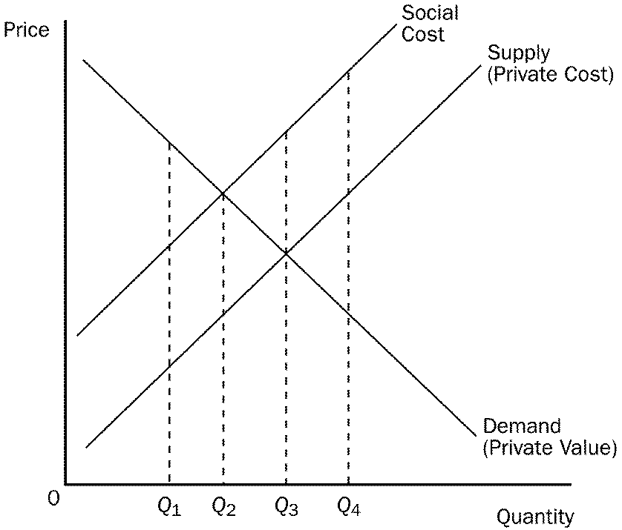
58. Refer to Figure 10-3. This market is experiencing
a. government intervention.
b. a positive externality.
c. a negative externality.
d. None of the above are correct.
ANS: C a negative externality.
DIF: 2 SECTION: 1 TYPE: M
59. Refer to Figure 10-3. The equilibrium quantity would be at
a. Q₁.
b. Q₂.
c. Q₃.
d. Q₄.
ANS: C Q₃.
DIF: 2 SECTION: 1 TYPE: M
60. Refer to Figure 10-3. The optimum amount of this product from society's standpoint would be
a. Q₁.
b. Q₂.
c. Q₃.
d. Q₄.
ANS: B Q₂.
DIF: 2 SECTION: 1 TYPE: M
61. Refer to Figure 10-3. At Q₃
a. the marginal consumer values this product less than the social cost of producing it.
b. every consumer values this product less than the social cost of producing it.
c. the cost to society is equal to the value to society.
d. the marginal consumer values this product more than the private cost.
ANS: A the marginal consumer values this product less than the social cost of producing it.
DIF: 3 SECTION: 1 TYPE: M
62. Refer to Figure 10-3. If this market currently produces Q₃, total economic well-being would be increased if
a. production decreased to Q₂.
b. production increased to Q₄.
c. this product were no longer produced.
d. Since well-being is maximized at Q₃ it cannot be increased.
ANS: A production decreased to Q₂.
DIF: 3 SECTION: 1 TYPE: M
63. Refer to Figure 10-3. This market
a. has no need for government intervention.
b. would benefit from a tax on the product.
c. would benefit from a subsidy placed on the product.
d. would optimize total well-being at Q₃.
ANS: B would benefit from a tax on the product.
DIF: 2 SECTION: 1 TYPE: M
64. Refer to Figure 10-3. If this market is currently producing at Q₁, then total economic well-being would increase if output
a. increased to Q₂.
b. increased to Q_{3.}.
c. increased to Q₄.
d. stayed at Q₁.
ANS: A increased to Q₂.
DIF: 1 SECTION: 1 TYPE: M
65. Refer to Figure 10-3. If this market is currently producing at Q₄, then total economic well-being would increase if output
a. increased.
b. decreased to Q₂.
c. decreased to zero.
d. stayed at Q₄.
ANS: B decreased to Q₂.
DIF: 2 SECTION: 1 TYPE: M
66. Refer to Figure 10-3. If all external costs were internalized, then the market's equilibrium output would be
a. Q₁.
b. Q₂.
c. Q₃.
d. Q₄.
ANS: B Q₂.
DIF: 2 SECTION: 1 TYPE: M
67. Refer to Figure 10-3. If this market currently produces Q₂, total economic well-being would be maximized if
a. production decreased to Q₁.
b. production increased to Q₃.
c. this product were no longer produced.
d. output stayed at Q₂.
ANS: D output stayed at Q₂.
DIF: 2 SECTION: 1 TYPE: M
68. Refer to Figure 10-3. Externalities in this market could be internalized if
a. there were a tax on the product.
b. there were a subsidy on the product.
c. production were stopped.
d. the Coase Theorem failed.
ANS: A there were a tax on the product.
DIF: 3 SECTION: 1 TYPE: M
69. Internalizing an externality refers to making
a. buyers and sellers take into account the external effects of their actions.
b. certain that all market transaction benefits go to only buyers and sellers.
c. certain government does not disrupt the internal workings of the market.
d. buyers pay the full price for the products they purchase.
ANS: A buyers and sellers take into account the external effects of their actions.
DIF: 2 SECTION: 1 TYPE: M
70. Suppose that a steel factory emits a certain amount of air pollution, which constitutes a negative externality. If this market is not required to internalize this externality,
a. the supply curve would adequately reflect the marginal social cost of production.
b. consumers will be required to pay a higher price for steel than they would have if the externality were internalized.
c. the market equilibrium would not be the socially optimal quantity.
d. producers will produce less steel than they otherwise would have if the externality were internalized.
ANS: C the market equilibrium would not be the socially optimal quantity.
DIF: 2 SECTION: 1 TYPE: M
71. A fertilizer plant emits a very foul odor during the production process. If the government forces the plant to internalize this negative externality, then the
a. supply curve for fertilizer would shift to the right (down).
b. supply curve for fertilizer would shift to the left (up).
c. demand curve for fertilizer would shift to the right (down).
d. demand curve for fertilizer would shift to the left (up).
ANS: B supply curve for fertilizer would shift to the left (up).
DIF: 3 SECTION: 1 TYPE: M
72. Suppose that a steel factory emits a certain amount of air pollution, which constitutes a negative externality. The social cost of producing the steel includes the
a. private costs of the steel producers and the price consumers pay for the steel.
b. private costs of the steel producers and the costs to the bystanders affected by the pollution.
c. costs to the bystanders effected by the pollution only.
d. price consumers pay for the steel.
ANS: B private costs of the steel producers and the costs to the bystanders affected by the pollution.
DIF: 2 SECTION: 1 TYPE: M
73. Which of the following statements is most correct about a market which is characterized by a negative production externality?
a. The equilibrium quantity of output is equal to the socially optimal quantity.
b. The equilibrium quantity of output is greater than the socially optimal quantity.
c. Government intervention is not required to achieve a socially optimal quantity of output.
d. The cost to the producer exceeds the cost to society.
ANS: B The equilibrium quantity of output is greater than the socially optimal quantity.
DIF: 2 SECTION: 1 TYPE: M
74. When a market is in equilibrium and the marginal consumer values a commodity at less than the social cost of producing it, then
a. at market equilibrium the demand curve lies below the social cost curve.
b. reducing production to a level below the equilibrium level could possibly raise total economic well-being.
c. the equilibrium price is higher than necessary to insure maximum economic well-being.
d. All of the above are correct.
e. Both a and b are correct.
ANS: E Both a and b are correct.
DIF: 3 SECTION: 1 TYPE: M
75. When producers operate in a market characterized by negative externalities, a tax that forces them to internalize the externality will
a. give sellers the incentive to account for the external effects of their actions.
b. have an offsetting effect that reduces the producers' private production costs.
c. increase the amount of the commodity exchanged in market equilibrium.
d. restrict the producers' ability to take the costs of the externality into account when deciding how much to supply.
ANS: A give sellers the incentive to account for the external effects of their actions.
DIF: 2 SECTION: 1 TYPE: M
76. An optimal tax on pollution (a negative externality) would be one in which
a. producers choose not to produce any pollution.
b. producers internalize the cost of the pollution.
c. a benevolent social planner is able to maximize production.
d. the value to consumers at market equilibrium exceeds the cost of production (including tax).
ANS: B producers internalize the cost of the pollution.
DIF: 2 SECTION: 1 TYPE: M
Figure 10-5

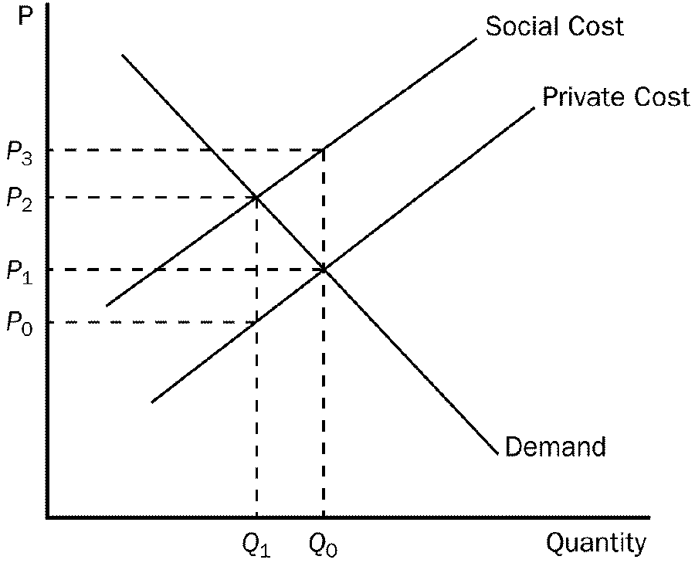
77. Refer to Figure 10-5. The marginal
a. benefit of the positive externality is measured by P₃ - P₁.
b. cost of the negative externality is measured by P₃ - P₂.
c. cost of the negative externality is measured by P₃ - P₁.
d. cost of the negative externality is measured by P₃ - P₀.
ANS: C cost of the negative externality is measured by P₃ - P₁.
DIF: 3 SECTION: 1 TYPE: M
78. Refer to Figure 10-5. Which price and quantity combination represents the social optimum?
a. P₀ and Q₁.
b. P₂ and Q₁.
c. P₁ and Q₂.
d. P₂ and Q₂.
ANS: B P₂ and Q₁.
DIF: 2 SECTION: 1 TYPE: M
79. Internalizing a positive externality will cause the supply curve of an industry to
a. shift to the right.
b. shift to the left.
c. become more elastic.
d. remain unchanged.
ANS: A shift to the right.
DIF: 2 SECTION: 1 TYPE: M
80. Internalizing a negative externality will cause the supply curve of an industry to
a. shift to the right.
b. shift to the left.
c. expand.
d. remain unchanged.
ANS: B shift to the left.
DIF: 2 SECTION: 1 TYPE: M
81. Which of the following is true concerning government attempts to internalize externalities?
a. Government should tax goods with negative externalities and subsidize goods with positive externalities.
b. Government should tax goods with either positive or negative externalities.
c. Government should subsidize goods with either positive or negative externalities.
d. Government should tax goods with positive externalities and subsidize goods with negative externalities.
ANS: A Government should tax goods with negative externalities and subsidize goods with positive externalities.
DIF: 3 SECTION: 1 TYPE: M
82. Which of the following statements about internalizing a negative externality is most correct?
a. Internalizing a negative externality will cause an industry to decrease the quantity it supplies to the market and decrease the price of the good produced.
b. Internalizing a negative externality will cause an industry to decrease the quantity it supplies to the market and increase the price of the good produced.
c. Internalizing a negative externality will cause an industry to increase the quantity it supplies to the market and decrease the price of the good produced.
d. Internalizing a negative externality will cause an industry to increase the quantity it supplies to the market and increase the price of the good produced.
ANS: B Internalizing a negative externality will cause an industry to decrease the quantity it supplies to the market and increase the price of the good produced.
DIF: 3 SECTION: 1 TYPE: M
83. The government can internalize a positive externality by
a. taxing production which would decrease supply.
b. taxing production which would increase supply.
c. subsidizing production which would decrease supply.
d. subsidizing production which would increase supply.
ANS: D subsidizing production which would increase supply.
DIF: 2 SECTION: 1 TYPE: M
84. Technology spillover occurs when
a. a firm passes the high costs of technical research on to society through higher prices.
b. a firm's research yields technical knowledge that is used by society as a whole.
c. the government subsidizes firms engaged in high-tech research.
d. copyright laws prohibit firms from profiting from the research of others.
ANS: B a firm's research yields technical knowledge that is used by society as a whole.
DIF: 2 SECTION: 1 TYPE: M
85. Technology spillover is one type of
a. negative externality.
b. positive externality.
c. subsidy.
d. producer surplus.
ANS: B positive externality.
DIF: 1 SECTION: 1 TYPE: M
86. Which of the following best defines the situation where one firm's research yields knowledge that is used by society as a whole?
a. social cost
b. opportunity cost of technology
c. internalization of an externality
d. technology spillover
ANS: D technology spillover
DIF: 1 SECTION: 1 TYPE: M
87. Technology spillover means that
a. it is the government's responsibility to subsidize firms which are engaged in high-tech research.
b. a firm's research yields technological knowledge that can then be used by society as a whole.
c. those firms engaged in technology research may be taxed by the government if that research causes negative externalities in the market.
d. when firms invest in the latest production technology, the cost of that technology "spills over" to the prices consumers must pay for the product.
ANS: B a firm's research yields technological knowledge that can then be used by society as a whole.
DIF: 2 SECTION: 1 TYPE: M
88. If the government wanted to ensure that the market reaches the social optimum in the presence of a technology spillover, it should
a. impose a Pigovian tax on any firm producing a technology spillover.
b. offer tax credits to consumers who are adversely affected by the new technology.
c. subsidize producers by an amount equal to the value of the technology spillover.
d. provide research grants to those firms not currently engaging in research to increase competition in the industry.
ANS: C subsidize producers by an amount equal to the value of the technology spillover.
DIF: 2 SECTION: 1 TYPE: M
89. Which of the following statements about a market that is affected by a positive externality is correct?
a. The optimum level of output is less than the free market level of output and the optimum price is greater than the free market price.
b. The optimum level of output is greater than the free market level of output and the optimum price is less than the free market price.
c. The optimum level of output is greater than the free market level of output and the optimum price is greater than the free market price.
d. The optimum level of output is less than the free market level of output and the optimum price is less than the free market price.
ANS: B The optimum level of output is greater than the free market level of output and the optimum price is less than the free market price.
DIF: 3 SECTION: 1 TYPE: M
90. A market that experiences a positive externality will also experience a
a. smaller market output and a higher market price than is optimal.
b. greater market output and lower market price than is optimal.
c. greater market output and higher market price than is optimal.
d. smaller market output and lower market price than is optimal.
ANS: D smaller market output and lower market price than is optimal.
DIF: 3 SECTION: 1 TYPE: M
91. To enhance the well-being of society, a social planner will encourage firms to increase production when
a. the firms are producing basic goods.
b. there is a shortage in the market.
c. technology spillovers are associated with production.
d. any negative externalities associated with production are imposed only upon consumers.
ANS: C technology spillovers are associated with production.
DIF: 2 SECTION: 1 TYPE: M
92. A positive externality will cause a market to produce
a. more than is socially desirable.
b. more than is market optimal.
c. less than is socially desirable.
d. less than is market optimal.
ANS: C less than is socially desirable.
DIF: 2 SECTION: 1 TYPE: M
93. Internalizing a positive externality through a government subsidy will cause the industry's supply curve to
a. remain unchanged.
b. shift down by an amount less than the subsidy.
c. shift down by an amount equal to the subsidy.
d. shift down by an amount greater than the subsidy.
ANS: C shift down by an amount equal to the subsidy.
DIF: 3 SECTION: 1 TYPE: M
94. To ensure the market reaches the social optimum in presence of a technology spillover, the government should subsidize producers by
a. use of a Pigovian tax
b. an amount equal to the value of the technology spillover
c. helping those companies that are adversely affected by the new technology.
d. transferring income to the low-income portion of the population.
ANS: B an amount equal to the value of the technology spillover
DIF: 2 SECTION: 1 TYPE: M
95. With technology spillover, to ensure that the market equilibrium equals the social optimum, government should
a. impose a tax greater than the value of the technology spillover.
b. not allow production of any product that causes a technology spillover.
c. provide a subsidy equal to the value of the technology spillover.
d. require producers to "clean up" any spillover that results from their production process.
ANS: C provide a subsidy equal to the value of the technology spillover.
DIF: 2 SECTION: 1 TYPE: M
96. If making computer chips yields greater spillovers than making potato chips, some economists would argue that government should
a. encourage the production of computer chips with subsidies.
b. discourage the production of potato chips with taxes.
c. encourage the production of potato chips with subsidies.
d. discourage the production of computer chips with taxes.
ANS: A encourage the production of computer chips with subsidies.
DIF: 2 SECTION: 1 TYPE: M
97. Government intervention that aims to promote technology-enhancing industries is called
a. assisted technology.
b. intervention policy.
c. industrial technology assistance.
d. industrial policy.
ANS: D industrial policy.
DIF: 1 SECTION: 1 TYPE: M
98. One drawback to industrial policy is that
a. technology spillovers often appear equivalent to policymakers.
b. measuring the size of spillovers from different markets is difficult.
c. spillovers often occur in industries that produce undesirable products for society.
d. positive side effects are often outweighed by negative side effects.
ANS: B measuring the size of spillovers from different markets is difficult.
DIF: 2 SECTION: 1 TYPE: M
99. With industrial policy, the belief is that
a. industries yielding the largest positive externalities should receive the biggest subsidies.
b. any industry which produces negative externalities should be heavily taxed.
c. any production process which produces negative externalities must be shut down.
d. any industry which produces a positive externality should be encouraged with subsidies.
ANS: A industries yielding the largest positive externalities should receive the biggest subsidies.
DIF: 2 SECTION: 1 TYPE: M
100. One way to internalize a technology spillover is
a. with taxes.
b. with patents.
c. with government regulations.
d. allowing free markets to work.
ANS: B with patents.
DIF: 1 SECTION: 1 TYPE: M
101. A patent is used to
a. disseminate information.
b. restrict ownership.
c. protect inventors for as long as they live.
d. assign property rights.
ANS: D assign property rights.
DIF: 2 SECTION: 1 TYPE: M
102. Patents do NOT
a. provide firms an incentive to research.
b. assign property rights to inventors.
c. protect the rights of inventors for their lifetime.
d. internalize externalities.
ANS: C protect the rights of inventors for their lifetime.
DIF: 2 SECTION: 1 TYPE: M
103. A positive externality occurs when
a. Jack receives a benefit from John's consumption of a certain good.
b. Jack receives personal benefits from his own consumption of a certain good.
c. Jack's benefit exceeds John's benefit when they each consume the same good.
d. Jack's consumption is not beneficial to John.
ANS: A Jack receives a benefit from John's consumption of a certain good.
SECTION: 1 TYPE: M
104. When a market experiences a positive externality,
a. the demand curve does not reflect the value to society of the good.
b. too much of the good is being produced.
c. the government can internalize the externality by imposing a tax on the product.
d. the private value is greater than the social value.
ANS: A the demand curve does not reflect the value to society of the good.
DIF: 2 SECTION: 1 TYPE: M
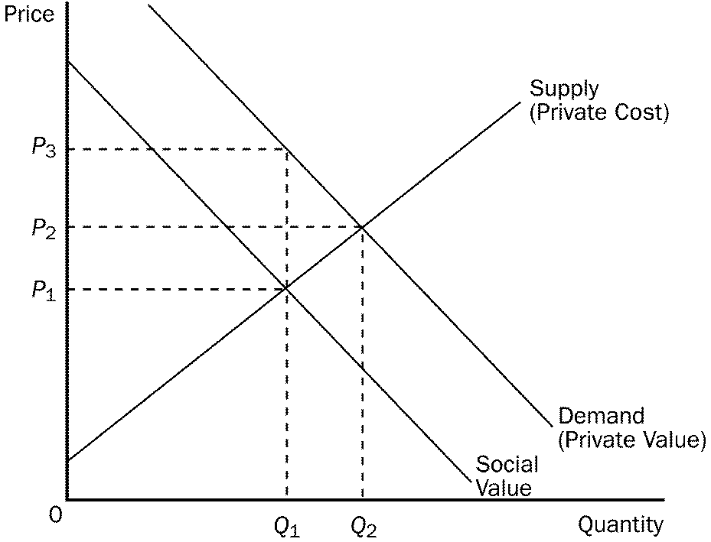
Figure 10-6
105. Refer to Figure 10-6. Which price and quantity combination represents the social optimum for this market?
a. P₁ and Q₁.
b. P₂ and Q₂.
c. P₂ and Q₁.
d. P₃ and Q_{1.}
ANS: A P₁ and Q₁.
DIF: 2 SECTION: 1 TYPE: M
106. Refer to Figure 10-6. To internalize the externality in this market the government should
a. impose a tax on this product.
b. provide a subsidy for this product.
c. encourage firms to supply more of this product by offering tax incentives.
d. produce the product itself.
ANS: A impose a tax on this product.
DIF: 2 SECTION: 1 TYPE: M
107. A negative externality will cause a private market to produce
a. less than is socially desirable.
b. more than is socially desirable.
c. more than market equilibrium.
d. less than market equilibrium.
ANS: B more than is socially desirable.
DIF: 2 SECTION: 1 TYPE: M
108. A positive externality will cause a private market to produce
a. less than is socially desirable.
b. more than is socially desirable.
c. more than market equilibrium.
d. less than market equilibrium.
ANS: A less than is socially desirable.
DIF: 2 SECTION: 1 TYPE: M

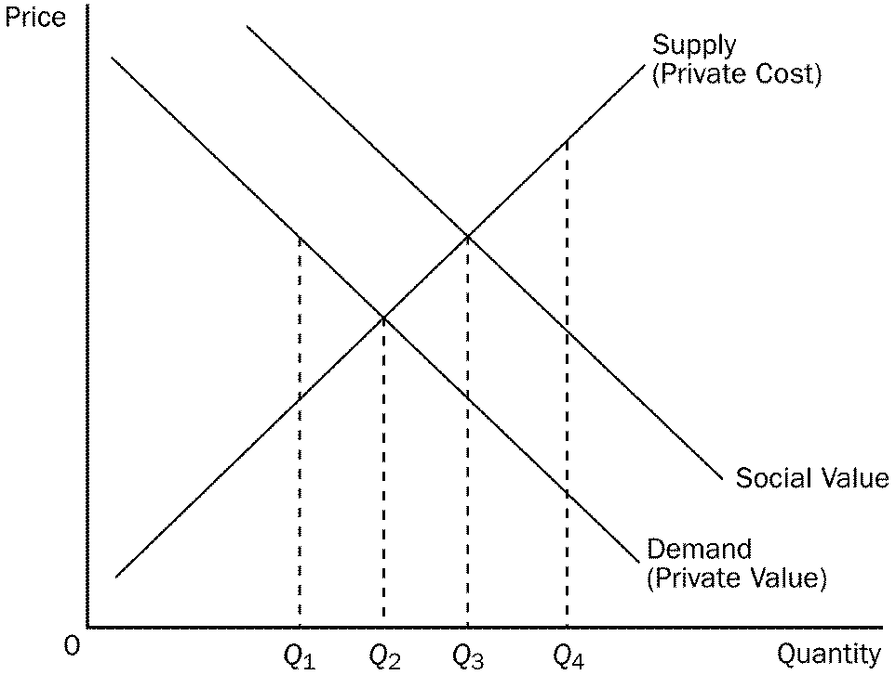
Figure 10-7
109. Refer to Figure 10-7. Which quantity represents the social optimum for this market?
a. Q_{1.}
b. Q₂.
c. Q_{3.}
d. Q_{4.}
ANS: C Q_{3.}
DIF: 2 SECTION: 1 TYPE: M
110. Refer to Figure 10-7. To internalize the externality in this market the government should
a. impose a tax on this product.
b. provide a subsidy for this product.
c. encourage firms to supply more of this product by taxing them.
d. produce the product itself.
ANS: B provide a subsidy for this product.
DIF: 2 SECTION: 1 TYPE: M
111. When dealing with externalities, government
a. can correct the market failure only in the case of positive externalities.
b. can correct the market failure only in the case of negative externalities.
c. can correct the market failure in both the positive and negative externalities by inducing market participants to internalize the externality.
d. cannot correct for externalities due to consumer rights laws.
ANS: C can correct the market failure in both the positive and negative externalities by inducing market participants to internalize the externality.
DIF: 3 SECTION: 1 TYPE: M
112. When dealing with externalities, the market equilibrium can be moved closer to the social equilibrium by
a. taxing negative externalities and subsidizing positive externalities.
b. taxing both positive and negative externalities.
c. subsidizing both positive and negative externalities.
d. None of the above are correct because government has no corrective policy with regards to externalities.
ANS: A taxing negative externalities and subsidizing positive externalities.
DIF: 2 SECTION: 1 TYPE: M
113. Private markets fail to reach a socially optimal level when negative externalities are present because
a. social costs equal private costs at the private market solution.
b. private costs exceed social costs at the private market solution.
c. social costs exceed private costs at the private market solution.
d. they internalize externalities.
ANS: C social costs exceed private costs at the private market solution.
DIF: 2 SECTION: 1 TYPE: M
114. Private markets fail to reach a socially optimal level when positive externalities are present because.
a. private benefit equals social benefit at the private market solution.
b. private costs exceed private benefits at the private market solution.
c. social value exceeds private value at the private market solution.
d. private costs exceed social benefit at the private market solution.
ANS: C social value exceeds private value at the private market solution.
DIF: 2 SECTION: 1 TYPE: M
115. Which of the following is true of positive externalities?
a. Social value exceeds private value and market quantity exceeds the socially optimal quantity.
b. Social value is less than private value and market quantity exceeds the socially optimal quantity.
c. Social value exceeds private value and market quantity is less than the socially optimal quantity.
d. Social value seldom exceeds private value and therefore social quantity is less than private quantity.
ANS: C Social value exceeds private value and market quantity is less than the socially optimal quantity.
DIF: 3 SECTION: 1 TYPE: M
116. All remedies for externalities share the goal of
a. moving the allocation of resources toward the market equilibrium.
b. moving the allocation of resources toward the social optimum.
c. increasing the allocation of resources.
d. decreasing the allocation of resources.
ANS: B moving the allocation of resources toward the social optimum.
DIF: 2 SECTION: 2 TYPE: M
117. Since externalities tend to keep markets from reaching a socially optimal equilibrium, government action
a. is always needed, because private solutions can never be attained.
b. is needed when private solutions fail to arise.
c. will be needed only to correct for positive externalities.
d. will be needed only to compensate consumers.
ANS: B is needed when private solutions fail to arise.
DIF: 2 SECTION: 2 TYPE: M
118. Externalities tend to cause markets to be
a. inefficient.
b. unequitable.
c. unnecessary.
d. overwhelmed.
ANS: A inefficient.
DIF: 1 SECTION: 2 TYPE: M
119. Many times the problems of externalities are solved by each of the following EXCEPT
a. self-interest.
b. moral codes and social sanctions.
c. charity.
d. normal market adjustments.
ANS: D normal market adjustments.
DIF: 1 SECTION: 2 TYPE: M
120. Firms that are involved in more than one type of business could be evidence of an attempt to
a. increase private profit at the expense of consumers.
b. internalize some forms of positive externalities.
c. reduce the impact of government regulation on their business.
d. increase the marginal external cost of production.
ANS: B internalize some forms of positive externalities.
DIF: 2 SECTION: 2 TYPE: M
121. Private contracts between parties with mutual interests
a. can only reduce the well-being of society.
b. will always lead to market outcomes in which the public interest is sacrificed for personal gain.
c. can solve some inefficiencies associated with positive externalities.
d. will always cause negative externalities to arise.
ANS: C can solve some inefficiencies associated with positive externalities.
DIF: 2 SECTION: 2 TYPE: M
122. The Golden Rule can be used as a private solution for
a. reducing crime.
b. internalizing externalities.
c. coping with overproduction.
d. coping with scarcity.
ANS: B internalizing externalities.
DIF: 1 SECTION: 2 TYPE: M
123. Two types of private solutions to the problem of externalities are
a. charities and the Golden Rule.
b. charities and subsidies.
c. the Golden Rule and taxes.
d. taxes and subsidies.
ANS: A charities and the Golden Rule.
DIF: 1 SECTION: 2 TYPE: M
124. When externalities cause markets to be inefficient
a. government action is always needed to solve the problem.
b. private solutions can be developed to solve the problem.
c. given enough time, externalities can be solved through normal market adjustments.
d. there is no way to eliminate the problem of externalities in a market.
ANS: B private solutions can be developed to solve the problem.
DIF: 1 SECTION: 1 TYPE: M
125. Two ways that private markets can solve the problem of externalities is with
a. integrating businesses and subsidies.
b. contracts and patents.
c. integrating businesses and contracts.
d. subsidies and patents.
ANS: C integrating businesses and contracts.
DIF: 2 SECTION: 2 TYPE: M
126. Which of the following choices suggests that the private market can be effective in dealing with externalities?
a. the "invisible hand"
b. the law of diminishing social returns
c. the Coase theorem
d. technology policy
ANS: C the Coase theorem
DIF: 1 SECTION: 2 TYPE: M
127. According to the Coase theorem, private parties can solve the problem of externalities if
a. the cost of bargaining is small.
b. the initial distribution of rights favors the person being adversely affected by the externality.
c. the number of parties involved is sufficiently large.
d. All of the above are correct.
ANS: A the cost of bargaining is small.
DIF: 2 SECTION: 2 TYPE: M
128. According to the Coase theorem, private markets will solve externality problems and allocate resources efficiently as long as
a. private parties can bargain without cost.
b. government assigns property rights to the harmed party.
c. the externalities that are present are positive and not negative.
d. businesses determine an appropriate level of production.
ANS: A private parties can bargain without cost.
DIF: 2 SECTION: 2 TYPE: M
129. Dick owns a dog whose barking annoys Dick's neighbor Jane. Suppose that the benefit of owning the dog is worth $500 to Dick and that Jane bears a cost of $700 from the barking. Assuming Dick has the legal right to keep the dog, a possible private solution to this problem is that
a. Jane pays Dick $500 to get rid of the dog.
b. Dick pays Jane $650 for her inconvenience.
c. Jane pays Dick $650 to get rid of the dog.
d. There is no private solution that would improve this situation.
ANS: C Jane pays Dick $650 to get rid of the dog.
DIF: 3 SECTION: 2 TYPE: M
130. Dick owns a dog whose barking annoys Dick's neighbor Jane. Suppose that the benefit of owning the dog is worth $700 to Dick and that Jane bears a cost of $500 from the barking. Assuming Dick has the legal right to keep the dog, a possible private solution to this problem is that
a. There is no private solution that would improve this situation.
b. Jane pays Dick $650 to get rid of the dog.
c. Jane pays Dick $800 to get rid of the dog.
d. Dick pays Jane $600 for her inconvenience.
ANS: A There is no private solution that would improve this situation.
DIF: 3 SECTION: 2 TYPE: M
131. Dick owns a dog whose barking annoys Dick's neighbor Jane. Dick receives personal benefit from owning the dog, and Jane bears a cost of Dick's ownership of the dog. Assuming Dick has the legal right to keep the dog, which of the following choices are true?
a. A private solution can always be arranged.
b. A private solution can be arranged only if the cost Jane bears exceeds the benefit Dick gets from his dog.
c. A private solution can be arranged only if Jane's cost equals Dick's benefit from the dog.
d. A private solution can be arranged only if Dick's benefit from his dog exceeds Jane's cost.
ANS: B A private solution can be arranged only if the cost Jane bears exceeds the benefit Dick gets from his dog.
DIF: 3 SECTION: 2 TYPE: M
132. Dick owns a dog whose barking annoys Dick's neighbor Jane. Dick receives personal benefit from owning the dog, and Jane bears a cost of Dick's ownership of the dog. Assuming Jane has the legal right to peace and quiet, which of the following statements is true?
a. If Dick's benefit exceeds Jane's cost, government intervention is necessary.
b. Dick will pay to keep his dog if his benefit exceeds Jane's cost.
c. If Jane's cost exceeds Dick's benefit, Dick will pay Jane to keep his dog.
d. If Jane has legal right to peace and quiet, she only has to pay Dick when her cost is below his benefit.
ANS: B Dick will pay to keep his dog if his benefit exceeds Jane's cost.
DIF: 2 SECTION: 2 TYPE: M
133. Chad's maple tree hangs over Amy's fence and drops leaves into her yard each autumn. The benefit to Chad of lower utility bills is about $300. The cost to Amy of having her lawn cleaned and reseeded is $350. Based on the Coase theorem
a. Amy should pay Chad $325 to cut down the tree.
b. Chad should pay Amy $350 to have her lawn repaired and cleaned.
c. Chad should pay Amy $400 to keep the tree.
d. Amy should build a higher fence.
ANS: A Amy should pay Chad $325 to cut down the tree.
DIF: 3 SECTION: 2 TYPE: M
134. Which of the following is true of the Coase theorem?
a. Interested parties can reach an outcome in which everyone is better off.
b. The outcome reached will be inefficient.
c. Interested parties will need an arbitrator in order to reach an agreement that is efficient.
d. None of the above is correct.
ANS: A Interested parties can reach an outcome in which everyone is better off.
DIF: 2 SECTION: 2 TYPE: M
135. The Coase theorem suggests that private markets may not be able to solve the problem of externalities
a. when the number of interested parties is large and bargaining costs are high.
b. if government does not actively become involved in the process.
c. if the firm in the market is a monopoly.
d. if some people benefit from the externality.
ANS: A when the number of interested parties is large and bargaining costs are high.
DIF: 2 SECTION: 2 TYPE: M
136. According to the Coase theorem
a. private parties can bargain to reach an efficient outcome.
b. government assistance is necessary for markets with externalities to reach an efficient outcome.
c. externalities, both positive and negative, will always cause markets to be inefficient.
d. no market will experience long-term externalities, since normal market adjustments will eliminate externalities.
ANS: A private parties can bargain to reach an efficient outcome.
DIF: 2 SECTION: 2 TYPE: M
137. Private solutions often are not possible due to the costs of negotiating and enforcing these solutions. Such costs are called
a. transaction costs.
b. opportunity costs.
c. deadweight loss.
d. Pigovian taxes.
ANS: A transaction costs.
DIF: 1 SECTION: 2 TYPE: M
138. Transaction costs
a. can keep private parties from solving externality problems.
b. are incurred in the production process due to externalities.
c. result from transaction complications between buyers and sellers due to externalities.
d. will be eliminated in a market with externalities with government assistance.
ANS: A can keep private parties from solving externality problems.
DIF: 2 SECTION: 2 TYPE: M
139. One reason private solutions to externalities do not always work is because
a. government participation in such solutions complicates the process.
b. some people benefit from externalities.
c. interested parties incur costs in the bargaining process.
d. the actual costs and benefits of the problem are difficult to see.
ANS: C interested parties incur costs in the bargaining process.
DIF: 2 SECTION: 2 TYPE: M
140. When parties who are bargaining to eliminate an externality problem hold out for a better deal
a. the inefficient outcome persists.
b. the eventual outcome will maximize total well-being.
c. transaction costs must be low.
d. one party will gain more than the other party.
ANS: A the inefficient outcome persists.
DIF: 2 SECTION: 2 TYPE: M
141. Assuming transaction costs are small, the Coase Theorem is likely to be helpful in articulating a solution to a
a. neighborhood problem with unattended dogs running loose.
b. neighbor who doesn't care for his yard.
c. neighbor who deals drugs out of his house.
d. All of the above are correct.
ANS: D All of the above are correct.
DIF: 1 SECTION: 2 TYPE: M
142. If only a few people are affected by an externality, then it is likely that
a. Pigovian taxes will provide the most efficient solution to the externality.
b. command and control regulation will provide the most efficient solution to the externality.
c. a private solution to the inefficiency will occur.
d. a private solution will be very difficult to negotiate.
ANS: C a private solution to the inefficiency will occur.
DIF: 2 SECTION: 2 TYPE: M
143. Reaching an efficient bargain is difficult when the
a. externality is large.
b. number of interested parties is large.
c. externality is negative.
d. government becomes involved.
ANS: B number of interested parties is large.
DIF: 2 SECTION: 2 TYPE: M
144. Employing a lawyer to draft and enforce a private contract between parties wishing to solve an externality problem is an example of
a. an opportunity cost.
b. an implicit cost.
c. a sunk cost.
d. a transaction cost.
ANS: D a transaction cost.
DIF: 1 SECTION: 2 TYPE: M
145. Which of the following is one problem that keeps people from privately solving externalities?
a. Each party involved holds out for a better deal.
b. The externality is large.
c. Only problems with a sufficiently large number of parties can be solved.
d. There is a lack of government intervention.
ANS: A Each party involved holds out for a better deal.
DIF: 2 SECTION: 2 TYPE: M
146. In class action lawsuits interested parties to the lawsuit are not required to pay attorney fees directly. This is an example of an attempt to
a. increase attorney fees from a final judgment.
b. reduce the incentive of attorneys to take on class-action law suits.
c. reduce the transaction costs of finding a private solution to an externality.
d. regulate attorney fees in class action lawsuits.
ANS: C reduce the transaction costs of finding a private solution to an externality.
DIF: 2 SECTION: 2 TYPE: M
147. Nancy loves to landscape her yard, but her neighbor Lee places a low value on his landscaping. When Lee's grass is neglected and gets long, Nancy will mow it for Lee. This is an example of
a. a situation in which the Coase theorem fails to explain the lawn mowing arrangement.
b. improper allocation of resources.
c. a private solution to a negative externality problem.
d. an exploitation of a common resource.
ANS: C a private solution to a negative externality problem.
DIF: 2 SECTION: 2 TYPE: M
148. The Coase theorem suggests that private solutions to the externality problem
a. will always allocate resources efficiently if private parties can bargain without cost.
b. are effective under all conditions.
c. are only efficient when there are negative externalities.
d. may not be possible because of the distribution of property rights.
ANS: A will always allocate resources efficiently if private parties can bargain without cost.
DIF: 2 SECTION: 2 TYPE: M
149. Assume that your roommate, Vanessa, is very messy, which is not a crime at your campus. Suppose she gets a $100 benefit from being messy but imposes a $200 cost on you. The Coase theorem would suggest that an efficient solution would be for you to
a. pay your roommate at least $100 but no more than $200 to clean up after herself.
b. pay your roommate at least $201 to clean up after herself.
c. charge your roommate at least $100 to have you clean up after her.
d. charge your roommate at least $200 but no more than $300 to keep you from complaining about the mess.
ANS: A pay your roommate at least $100 but no more than $200 to clean up after herself.
DIF: 2 SECTION: 2 TYPE: M
150. Assume that your roommate, Vanessa, is very messy, and according to campus policy, you have a right to live in an uncluttered apartment. Suppose she gets a $200 benefit from being messy but imposes a $100 cost on you. The Coase theorem would suggest that an efficient solution would be for your roommate to
a. stop her messy habits or else move out.
b. pay you at least $100 but less than $200 to live with the clutter.
c. continue to be messy and force you to make other living arrangements elsewhere.
d. demand payment of at least $100 but no more than $200 to clean up after herself.
ANS: B pay you at least $100 but less than $200 to live with the clutter.
DIF: 2 SECTION: 2 TYPE: M
151. When the government reverts to a command-and-control policy to solve an externality, it
a. is usually the most effective policy option available.
b. creates policies that directly regulate behavior.
c. usually involves taxing consumption of a commodity.
d. typically refers to the Coase theorem to structure the policy.
ANS: B creates policies that directly regulate behavior.
DIF: 2 SECTION: 3 TYPE: M
152. When the government chooses an externality policy that aligns private incentives with social efficiency to solve an externality,
a. it provides incentives to private decision makers to induce them to solve the externality problem on their own.
b. it typically uses command-and-control techniques.
c. the use of taxes is strictly forbidden.
d. subsidies are always the best policy.
ANS: A it provides incentives to private decision makers to induce them to solve the externality problem on their own.
DIF: 2 SECTION: 3 TYPE: M
153. A local cafe which allowed patrons to smoke was recently forced to close its doors because it did not comply with local clean air standards. This decision provides an example of
a. direct regulation of an externality.
b. Pigovian taxes.
c. a Coase theorem solution to an externality.
d. unjustified discrimination against smokers.
ANS: A direct regulation of an externality.
DIF: 2 SECTION: 3 TYPE: M
154. In Singapore, littering fines are strictly enforced. This is an example of a policy
a. in which moral codes and social sanctions reduce the pollution externality.
b. that relies on the Coase Theorem.
c. that discriminates against foreigners.
d. in which private incentives are used to reduce the pollution externality in Singapore.
ANS: D a policy in which private incentives are used to reduce the pollution externality in Singapore.
DIF: 2 SECTION: 3 TYPE: M
155. Emission controls on automobiles are an example of a
a. Pigovian tax on automobiles, based on how much they pollute.
b. command-and-control policy to increase social efficiency.
c. policy that reduces pollution by allocating resources through market mechanisms.
d. policy to reduce congestion on urban freeways.
ANS: B a command-and-control policy to increase social efficiency.
DIF: 2 SECTION: 3 TYPE: M
156. Since almost all forms of transportation produce some type of pollution
a. the government should ban all transportation.
b. society has to weigh the cost and benefits and decide how much pollution to allow.
c. corporations should voluntarily reduce pollution levels with new car models.
d. the government should tax the types of transportation that pollute most to eliminate it altogether.
ANS: B society has to weigh the cost and benefits and decide how much pollution to allow.
DIF: 2 SECTION: 3 TYPE: M
157. Pigovian taxes are typically advocated to correct for the effects of
a. positive externalities.
b. negative externalities.
c. regulatory burden.
d. All of the above are correct.
ANS: B negative externalities.
DIF: 2 SECTION: 3 TYPE: M
158. Pigovian taxes are enacted to
a. raise revenue from those most able to pay.
b. correct the effects of negative externalities.
c. discourage production of undesirable products.
d. adjust markets with positive externalities.
ANS: B correct the effects of negative externalities.
DIF: 2 SECTION: 3 TYPE: M
159. Pigovian taxes
a. encourage consumers to avoid sales taxes by shopping online.
b. are frequently used to discourage imports.
c. are rarely preferred to direct regulation.
d. give factory owners an economic incentive to reduce pollution.
ANS: D give factory owners an economic incentive to reduce pollution.
DIF: 2 SECTION: 3 TYPE: M
160. Pigovian taxes are preferred over regulations to deal with pollution because Pigovian taxes
a. reduce pollution at a lower cost to society.
b. raise revenue and reduce pollution simultaneously, although efficiency is reduced.
c. obtain faster results than regulations.
d. allow for an accurate monitoring of pollution levels.
ANS: A reduce pollution at a lower cost to society.
DIF: 2 SECTION: 3 TYPE: M
161. Regulations to reduce pollution
a. cause each factory to reduce pollution to the same maximum level.
b. are a less costly solution to society than a Pigovian tax.
c. cause pollution levels to drop below the regulated amount.
d. are a better solution for the environment than a Pigovian tax.
ANS: A cause each factory to reduce pollution to the same maximum level.
DIF: 2 SECTION: 3 TYPE: M
162. A Pigovian tax
a. places a price on the right to pollute.
b. assigns a legal pollution limit for firms.
c. causes each factory to reduce pollution by the same amount.
d. causes higher cost to society than pollution regulations.
ANS: A places a price on the right to pollute.
DIF: 2 SECTION: 3 TYPE: M
163. Pigovian taxes differ from most taxes in that Pigovian taxes
a. enhance economic efficiency.
b. do not raise revenue from the government.
c. cause deadweight loss.
d. cannot be divided between the buyer and seller.
ANS: A enhance economic efficiency.
DIF: 2 SECTION: 3 TYPE: M
164. Which of the following statements is most correct?
a. Pigovian taxes are often preferred over direct regulation because they typically reduce externalities at a lower cost.
b. Pigovian taxes are less preferred than direct regulation because they typically reduce externalities at a higher cost.
c. Pigovian taxes are often preferred over direct regulation because they typically reduce externalities at a faster rate.
d. Pigovian taxes are less preferred than direct regulation because they typically reduce externalities at a slower rate.
ANS: A Pigovian taxes are often preferred over direct regulation because they typically reduce externalities at a lower cost.
DIF: 3 SECTION: 3 TYPE: M
165. If the government were to limit the release of air-pollution produced by a steel mill to 10,000 units, this policy would be considered a
a. regulation.
b. Pigovian tax.
c. subsidy.
d. market-based policy.
ANS: A regulation.
DIF: 1 SECTION: 3 TYPE: M
166. If the government were to impose a fee of $10,000 for each unit of air-pollution released by a steel mill, this policy would be considered a
a. subsidy.
b. regulation.
c. Pigovian tax.
d. command-and-control policy.
ANS: C Pigovian tax.
DIF: 1 SECTION: 3 TYPE: M
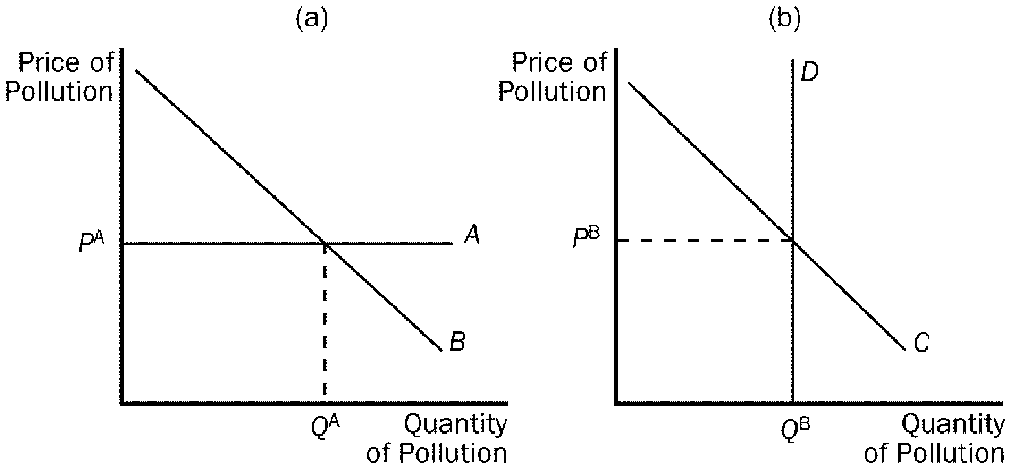
Figure 10-8
167. Refer to Figure 10-8. Which curve best represents a Pigovian tax?
a. A
b. B
c. C
d. D
ANS: A A
DIF: 3 SECTION: 3 TYPE: M
168. Refer to Figure 10-8. The equivalence of a Pigovian tax and a pollution permit would require each of the following EXCEPT that
a. P^{B} be equivalent to the Pigovian tax.
b. Q^{A} be equivalent to the amount of pollution allowed to the pollution permit holders.
c. the equilibrium price and quantity of pollution are the same in both panel A and panel B.
d. the amount of pollution emitted by each firm to be the same.
ANS: D the amount of pollution emitted by each firm to be the same.
DIF: 3 SECTION: 3 TYPE: M
169. A Pigovian tax
a. allocates pollution to those factories that face the highest cost of reducing it.
b. is a form of regulation.
c. works well for all types of externalities.
d. is deemed inferior to regulatory policy by most economists.
ANS: A allocates pollution to those factories that face the highest cost of reducing it.
DIF: 2 SECTION: 3 TYPE: M
170. Pigovian taxes are unlike most other taxes because they
a. distort incentives.
b. move the allocation of resources away from the social optimum.
c. raise revenue for the government.
d. move the allocation of resources closer to the social optimum.
ANS: D move the allocation of resources closer to the social optimum.
DIF: 3 SECTION: 3 TYPE: M
171. In many countries, one of the most heavily taxed goods is
a. food.
b. clothing.
c. hotel/recreation services.
d. gasoline.
ANS: D gasoline.
DIF: 2 SECTION: 3 TYPE: M
172. The tax on gasoline is an example of a/an
a. consumption tax.
b. Pigovian tax.
c. income tax.
d. command and control policy.
ANS: B Pigovian tax.
DIF: 2 SECTION: 3 TYPE: M
173. The gas tax is imposed to correct each of the following EXCEPT
a. congestion.
b. accidents.
c. pollution.
d. income inequality.
ANS: D income inequality.
DIF: 1 SECTION: 3 TYPE: M
174. One advantage of allowing a market for pollution permits to control the total amount of pollution released in an area is that
a. the government knows exactly how much each firm is allowed to pollute.
b. government revenue from the sale of permits is greater than revenue from a Pigovian tax.
c. the initial allocation of permits to firms does not affect the efficiency of the market.
d. firms will work together to eventually eliminate pollution.
ANS: C the initial allocation of permits to firms does not affect the efficiency of the market.
DIF: 3 SECTION: 3 TYPE: M
175. Two ways to reduce pollution which require firms to pay to pollute are
a. Pigovian taxes and pollution permits.
b. Pigovian taxes and a command-and-control policy.
c. pollution permits and a command-and-control policy.
d. pollution regulations and pollution permits.
ANS: A Pigovian taxes and pollution permits.
DIF: 2 SECTION: 3 TYPE: M
176. The difference between a Pigovian tax and pollution permits is
a. a Pigovian tax sets the price of pollution and permits set the quantity of pollution.
b. a Pigovian tax provides a more efficient outcome than permits.
c. a Pigovian tax sets the quantity of pollution and permits set the price of pollution.
d. permits provide a more efficient outcome than a Pigovian tax.
ANS: A a Pigovian tax sets the price of pollution and permits set the quantity of pollution.
DIF: 2 SECTION: 3 TYPE: M
177. In some cases, pollution permits may be better than a Pigovian tax because
a. pollution permits allow for a market solution while a Pigovian tax does not.
b. pollution permits generate more revenue for the government than a Pigovian tax.
c. Pollution permits are never preferred over a Pigovian tax.
d. the government can set a maximum level of pollution using permits.
ANS: D the government can set a maximum level of pollution using permits.
DIF: 2 SECTION: 3 TYPE: M
178. With a Pigovian tax, the supply curve for pollution rights is
a. elastic.
b. perfectly elastic.
c. inelastic.
d. perfectly inelastic.
ANS: B perfectly elastic.
DIF: 2 SECTION: 3 TYPE: M
179. With pollution permits, the supply curve for pollution rights is
a. elastic.
b. perfectly elastic.
c. inelastic.
d. perfectly inelastic.
ANS: D perfectly inelastic.
DIF: 2 SECTION: 3 TYPE: M
180. Once tradable pollution permits have been allocated to firms,
a. the government controls the price of permits.
b. firms that can reduce pollution only at high cost will be willing to pay the most for the pollution permits.
c. the value of pollution-saving technology is always lower than the market value of a pollution permit.
d. the total amount of pollution governed by the permit will always decrease.
ANS: B firms that can reduce pollution only at high cost will be willing to pay the most for the pollution permits.
DIF: 2 SECTION: 3 TYPE: M
181. When one firm sells its pollution permit to another firm, which of the following does NOT occur?
a. Both firms benefit.
b. The total amount of pollution remains the same.
c. Social welfare is enhanced.
d. Over time, pollution will be eliminated.
ANS: D Over time, pollution will be eliminated.
DIF: 2 SECTION: 3 TYPE: M
182. Some environmentalists argue that we should protect the environment as much as possible, regardless of cost. The implication of such a disregard for cost is likely to lead to each of the following EXCEPT
a. lower levels of nutrition, health care, and housing.
b. a lower standard of living.
c. slowing or reversing technological advancement.
d. the elimination of all pollution.
ANS: D the elimination of all pollution.
DIF: 2 SECTION: 3 TYPE: M
183. Tradable pollution permits
a. prices are set by the government.
b. will be bought by firms which can reduce pollution only at high costs.
c. are likely to create a higher level of total pollution.
d. are less desirable than Pigovian taxes in reducing pollution.
ANS: B will be bought by firms that can reduce pollution only at high costs.
DIF: 2 SECTION: 3 TYPE: M
184. According to an article in The Economist, negative externalities in the form of noise pollution can be caused by
a. barking dogs.
b. mobile phones.
c. public transportation.
d. children.
ANS: D children.
DIF: 2 SECTION: 3 TYPE: M
185. According to an article in The Economist children can
a. cause negative externalities.
b. cause positive externalities.
c. be allocated in a market setting, making the adoption process efficient.
d. increase costs to families much like taxes increase costs to firms.
ANS: A cause negative externalities.
DIF: 2 SECTION: 3 TYPE: M
186. The best remedy for market failure is often
a. properly redirected market forces.
b. central planning.
c. government regulations.
d. ignoring externalities.
ANS: A properly redirected market forces.
DIF: 2 SECTION: 3 TYPE: M
187. Children can be thought of as imposing negative externalities on airplane passengers because
a. when they cry, passengers bear a portion of the cost.
b. their tickets are free or obtained at reduced cost.
c. children (and their parents) are typically isolated in the rear of the airplane.
d. All of the above are correct.
ANS: A when they cry, passengers bear a portion of the cost.
DIF: 2 SECTION: 3 TYPE: M
188. If children impose a negative externality, the following must be true:
a. Parents would rather have fewer children.
b. Parent's costs exceed the benefits associated with having children.
c. Parents do not bear the full cost imposed by their children.
d. All of the above are true.
ANS: C Parents do not bear the full cost imposed by their children.
DIF: 2 SECTION: 3 TYPE: M
189. Which of the following policies is government most inclined to use when faced with a positive externality?
a. taxation
b. permits
c. subsidies
d. usage fees
ANS: C subsidies
DIF: 1 SECTION: 3 TYPE: M
190. If it is illegal for a biochemical manufacturer to release its waste into a nearby stream, then this is an example of
a. a market-based policy.
b. a command-and-control policy.
c. pollution permits.
d. transaction costs.
ANS: B a command-and-control policy.
DIF: 2 SECTION: 3 TYPE: M
191. Suppose that at present there are no laws to restrict pollution produced by the widget industry. The market price of a widget is $20. If the government imposes a tax equal in value to the cost of the pollution, then firms would continue to produce widgets if
a. the cost imposed by the pollution is less than $20 per widget produced.
b. the private cost of producing a widget equals the cost of the pollution generated per widget.
c. $20 minus the private cost of producing a widget is greater than the cost of the pollution generated per widget.
d. $20 minus the private cost of producing a widget is less than the cost of the pollution generated per widget.
ANS: C $20 minus the private cost of producing a widget is greater than the cost of the pollution generated per widget.
DIF: 3 SECTION: 1 TYPE: M
192. Anita enjoys growing flowers in her yard and has a lot of spare time, but can't afford the $100 it costs to buy flower seeds, fertilizer and water. Sally, who has a good view of Anita's yard, would also enjoy Anita's flowers. Sally has plenty of money but has no time to plant flowers. According to the Coase Theorem,
a. the city government should give Anita the $100 needed to grow flowers.
b. the city government should require Anita to grow flowers.
c. Sally and Anita might both be better off if Sally gave $100 to Anita to plant flowers.
d. Sally and Anita would definitely both be better off if Sally gave $100 to Anita to plant flowers.
ANS: C Sally and Anita might both be better off if Sally gave $100 to Anita to plant flowers.
DIF: 3 SECTION: 2 TYPE: M
193. In which of the following cases is the Coase Theorem most likely to work to solve the externality?
a. Richard is annoyed because his roommate smokes.
b. Chemicals from farms in the Mississippi Valley are polluting the Gulf of Mexico.
c. Car exhaust in a small town is making one of its residents ill.
d. Industrialization around the world is causing acid rain.
ANS: A Richard is annoyed because his roommate smokes.
DIF: 2 SECTION: 2 TYPE: M
194. A local laundry advertises that clothes it washes smell "sunshine fresh" because it line dries everything outside. Then a steel factory moves in next door and emits black smoke which stains the clothes drying at the laundry. According to the Coase Theorem, granting the
a. steel factory the right to pollute would be efficient, but granting the laundry the right to clean air would be equitable.
b. laundry the right to clean air would be efficient, but granting the steel factory the right to pollute would be equitable.
c. steel factory the right to pollute has the same effect on equity as granting the laundry the right to clean air.
d. steel factory the right to pollute has the same effect on efficiency as granting the laundry the right to clean air.
ANS: D steel factory the right to pollute has the same effect on efficiency as granting the laundry the right to clean air.
DIF: 2 SECTION: 2 TYPE: M
195. Which of the following statements is false?
a. Patents help internalize the externalities associated with technological advances.
b. Economists typically prefer regulations to Pigovian taxes because regulations provide more incentives for firms to seek continued reductions in pollution.
c. Allowing firms to trade pollution permits will lower the total cost of reducing pollution.
d. A big impediment to implementing the Coase Theorem in many cases is high transactions costs.
ANS: B Economists typically prefer regulations to Pigovian taxes because regulations provide more incentives for firms to seek continued reductions in pollution.
DIF: 2 SECTION: 3 TYPE: M
196. Two firms, A and B, each currently dump 50 tons of chemicals into the local river. The government has decided to reduce the pollution and from now on will require a pollution permit for each ton of pollution dumped into the river. The government gives each firm 20 pollution permits, which it can either use or sell to the other firm. It costs Firm A $100 for each ton of pollution that it eliminates before it reaches the river and it costs Firm B $50 for each ton of pollution that it eliminates before it reaches the river. After the two firms buy or sell pollution permits from each other, we would expect that Firm A will dump
a. 10 fewer tons of pollution into the river and Firm B will dump 50 fewer tons of pollution into the river.
b. 50 fewer tons of pollution into the river and Firm B will dump 10 fewer tons of pollution into the river.
c. 30 fewer tons of pollution into the river and Firm B will dump 30 fewer tons of pollution into the river.
d. 10 more tons of pollution into the river and Firm B will dump 50 fewer tons of pollution into the river.
ANS: A 10 fewer tons of pollution into the river and Firm B will dump 50 fewer tons of pollution into the river.
DIF: 3 SECTION: 3 TYPE: M
197. Two firms, A and B, each currently dump 50 tons of chemicals into the local river. The government has decided to reduce the pollution and from now on will require a pollution permit for each ton of pollution dumped into the river. The government gives each firm 20 pollution permits, which it can either use or sell to the other firm. It costs Firm A $100 for each ton of pollution that it eliminates before it reaches the river and it costs Firm B $50 for each ton of pollution that it eliminates before it reaches the river. It is likely that
a. Firm A will buy all of Firm B's pollution permits. Each one will cost between $50 and $100.
b. Firm B will buy all of Firm A's pollution permits. Each one will cost between $50 and $100.
c. Both firms will use their own pollution permits.
d. Firm A will buy all of Firm B's pollution permits. Each one will cost less than $50.
ANS: A Firm A will buy all of Firm B's pollution permits. Each one will cost between $50 and $100.
DIF: 3 SECTION: 3 TYPE: M
198. Two firms, A and B, each currently dump 50 tons of chemicals into the local river. The government has decided to reduce the pollution and from now on will require a pollution permit for each ton of pollution dumped into the river. It costs Firm A $100 for each ton of pollution that it eliminates before it reaches the river and it costs Firm B $50 for each ton of pollution that it eliminates before it reaches the river. The government gives each firm 20 pollution permits. Government officials are not sure whether to allow the firms to buy or sell the pollution permits to each other. What is the total cost of reducing pollution if firms are not allowed to buy and sell pollution permits from each other? What is the total cost of reducing pollution if the firms are allowed to buy and sell permits from each other?
a. $3,000; $1,500
b. $4,500; $3,500
c. $4,500; $4,000
d. $4,500; $2,500
ANS: B $4,500; $3,500
DIF: 3 SECTION: 3 TYPE: M
199. Two firms, A and B, each currently dump 20 tons of chemicals into the local river. The government has decided to reduce the pollution and from now on will require a pollution permit for each ton of pollution dumped into the river. The government gives each firm 10 pollution permits, which it can either use or sell to the other firm. It costs Firm A $100 for each ton of pollution that it eliminates before it reaches the river and it costs Firm B $50 for each ton of pollution that it eliminates before it reaches the river. After the two firms buy or sell pollution permits from each other, we would expect that
a. Firm A will no longer pollute and Firm B will not reduce its pollution at all.
b. Firm B will no longer pollute and Firm A will not reduce its pollution at all.
c. Firm A will dump 10 tons of pollution into the river and Firm B will dump 10 tons of pollution into the river.
d. Firm A will increase its pollution and Firm B will reduce its pollution.
ANS: B Firm B will no longer pollute and Firm A will not reduce its pollution at all.
DIF: 3 SECTION: 3 TYPE: M
200. Two firms, A and B, each currently dump 50 tons of chemicals into the local river. The government has decided to reduce the pollution and from now on will require a pollution permit for each ton of pollution dumped into the river. The government will sell 40 pollution permits for $75 each. It costs Firm A $100 for each ton of pollution that it eliminates before it reaches the river and it costs Firm B $50 for each ton of pollution that it eliminates before it reaches the river. It is likely that between the cost of permits and the cost of additional pollution abatement,
a. Firm B will spend $3,500.
b. Firm A will spend $4,000.
c. Firm A will spend $4,500.
d. Firm B will spend $3,000.
ANS: B Firm A will spend $4,000.
DIF: 3 SECTION: 3 TYPE: M
This figure reflects the market for outdoor concerts in a public park surrounded by residential neighborhoods.

Figure 10-2
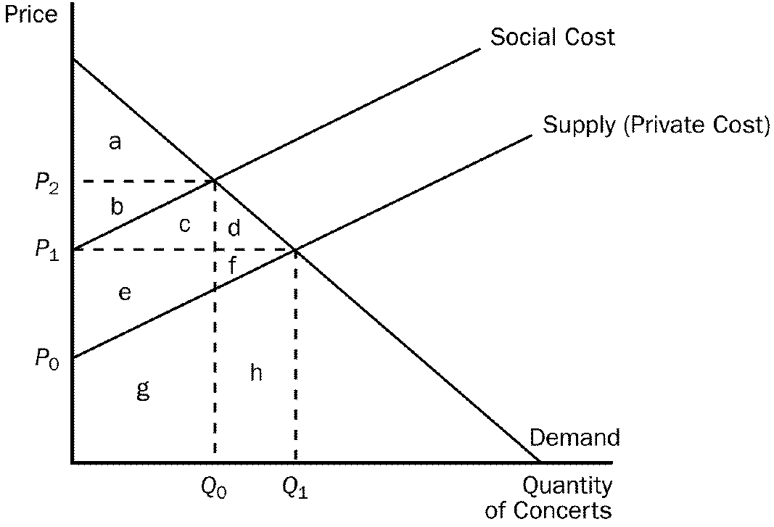
201. Refer to Figure 10-2. The social cost curve is above the supply curve because
a. it takes into account the external costs imposed on society by the concert organizers.
b. municipalities always impose noise restrictions on concerts in parks surrounded by residential neighborhoods.
c. concert tickets are likely to cost more than the concert actually costs the organizers.
d. residents in the surrounding neighborhoods get to listen to the concert for free.
ANS: A it takes into account the external costs imposed on society by the concert organizers.
DIF: 2 SECTION: 1 TYPE: M
202. Refer to Figure 10-2. The difference between the social cost curve and the supply curve reflects the
a. profit margin of each concert.
b. cost of spillover effects from the concert (e.g., noise and traffic).
c. value of concerts to society as a whole.
d. amount by which the city should subsidize the concert organizers.
ANS: B cost of spillover effects from the concert (e.g., noise and traffic).
DIF: 2 SECTION: 1 TYPE: M
203. Refer to Figure 10-2. What price and quantity combination best represents the optimum price and number of concerts that should be organized?
a. P₁, Q₁
b. P₂, Q₀
c. P₃, Q₁
d. The optimum quantity is zero concerts as long as residents in surrounding neighborhoods are adversely affected by noise and congestion.
ANS: B P₂ Q₀
DIF: 2 SECTION: 1 TYPE: M
204. Refer to Figure 10-2. Assume that the concert organizers must purchase a concert permit (the cost for the permit is included in private cost) before organizing the concert. What criteria should the city use in determining whether or not to issue a permit?
a. The majority vote of the residents in surrounding neighborhoods should determine whether a permit is issued.
b. As long as the value to consumers of concerts exceeds the cost of concerts (including the external costs) the permit should be issued.
c. As long as concert organizers are willing to return the park to its original condition after the concert, the permit should be issued.
d. The permit should not be issued as long as there are identifiable external costs imposed on residents in surrounding neighborhoods.
ANS: B As long as the value to consumers of concerts exceeds the cost of concerts (including the external costs) the permit should be issued.
DIF: 3 SECTION: 1 TYPE: M
205. Refer to Figure 10-2. Total surplus derived from the most efficient outcome is represented by the area
a. a + b.
b. a + b +c +d +e +f.
c. a + b +c +e +g.
d. a + b + c +d.
ANS: A a + b.
DIF: 3 SECTION: 1 TYPE: M
206. Refer to Figure 10-2. At the private market outcome, the equilibrium price will be
a. P₀.
b. P₁.
c. P₂.
d. P₃.
ANS: B P₁.
DIF: 2 SECTION: 1 TYPE: M

TRUE/FALSE
1. When a transaction between a buyer and seller directly affects a third party, the effect is called an externality.
ANS: T TYPE: T
2. In a market characterized by externalities, the market equilibrium fails to maximize the total benefit to society as a whole.
ANS: T TYPE: T
3. Negative externalities lead markets to produce a smaller quantity of a good than is socially desirable, while positive externalities lead markets to produce a larger quantity of a good than is socially desirable.
ANS: F TYPE: T
4. Barking dogs cannot be considered an externality because externalities must be associated with some form of market exchange.
ANS: F TYPE: T
5. Organizers of an outdoor concert in a park surrounded by residential neighborhoods are likely to consider the noise and traffic cost to residential neighborhoods when they assess the financial viability of the concert venture.
ANS: F SECTION: 1 TYPE: T
6. The social cost of pollution includes the private costs of the producers plus the costs to those bystanders affected adversely by the pollution.
ANS: T SECTION: 1 TYPE: T
7. Government intervention is necessary to correct all externalities.
ANS: F SECTION: 1 TYPE: T
8. Internalizing a negative externality will cause the market supply curve to shift to the left.
ANS: T SECTION: 1 TYPE: T
9. The government can internalize an externality by taxing goods that have negative externalities and subsidizing goods that have positive externalities.
ANS: T SECTION: 1 TYPE: T
10. If the social cost of producing robots is less than the private cost of producing robots, the private market produces too few robots.
ANS: T SECTION: 1 TYPE: T
11. The patent system gives firms greater incentive to engage in research and other activities that advance technology.
ANS: T SECTION: 1 TYPE: T
12. A technology spillover is a type of negative externality.
ANS: F SECTION: 1 TYPE: T
13. Government subsidized scholarships are an example of a government policy aimed at correcting for negative externalities associated with education.
ANS: F SECTION: 1 TYPE: T
14. According to the Coase theorem, if private parties can bargain without cost, then the private market will always solve the problem of externalities.
ANS: T SECTION: 2 TYPE: T
15. When people take into account how their actions affect others, the problem of externalities is solved.
ANS: T SECTION: 2 TYPE: T
16. According to the Coase theorem, whatever the initial distribution of rights, the interested parties can reach a bargain in which everyone is better off and the outcome is efficient.
ANS: T SECTION: 2 TYPE: T
17. According to the Coase theorem, the private market will need government intervention in order to reach an efficient outcome.
ANS: F SECTION: 2 TYPE: T
18. Despite the appealing logic of the Coase theorem, private actors often fail to resolve the problems caused by externalities on their own.
ANS: T SECTION: 2 TYPE: T
19. Private parties may choose to leave an externality problem unsolved if the transaction costs are large enough.
ANS: T SECTION: 2 TYPE: T
20. Government can be used to solve externality problems that are too costly for private parties to solve.
ANS: T SECTION: 2 TYPE: T
21. Despite the stated goals of some environmentalists, it would be impossible to prohibit all polluting activity.
ANS: T SECTION: 3 TYPE: T
22. When one business confers an externality on another business, the two businesses can internalize the externality by merging.
ANS: T SECTION: 3 TYPE: T
23. Most economists prefer regulation to taxation because regulation corrects market inefficiencies at a lower cost than taxation does.
ANS: F SECTION: 3 TYPE: T
24. When correcting for an externality, command-and-control policies are always preferable to market-based policies.
ANS: F SECTION: 3 TYPE: T
25. In essence, the Pigovian tax places a price on the right to pollute.
ANS: T SECTION: 3 TYPE: T
26. Equal reduction in pollution, among all firms, is the least expensive way to clean up the environment.
ANS: F SECTION: 3 TYPE: T
27. Pigovian taxes enhance efficiency, but the cost to administer the tax frequently exceeds the revenue they raise for the government.
ANS: F SECTION: 3 TYPE: T
28. Social welfare can be enhanced by allowing firms to trade their rights to pollute.
ANS: T SECTION: 3 TYPE: T
29. A market for pollution permits can efficiently allocate the right to pollute by the forces of supply and demand.
ANS: T SECTION: 3 TYPE: T
30. Firms that can reduce pollution easily would be willing to sell their pollution permits.
ANS: T SECTION: 3 TYPE: T
31. The Environmental Protection Agency (EPA) cannot reach a target level of pollution through the use of pollution permits.
ANS: F SECTION: 3 TYPE: T
32. Both pollution permits and Pigovian taxes are viewed as cost effective ways to keep the environment clean.
ANS: T SECTION: 3 TYPE: T
33. Luckily, the free market corrects for the cost to bystanders of a crying child, because the parent is irritated as much if not more than the bystander.
ANS: F SECTION: 3 TYPE: T

SHORT ANSWER
1. What is meant by "internalizing" an externality? How can a negative externality be internalized?
ANS: Internalizing an externality is when the parties to a market exchange perceive the external cost or benefit as a "cost" or "benefit" that accrues to them as part of the market exchange. One way of internalizing a negative externality is through a unit tax (Pigovian tax) on production and/or consumption.
SECTION: 1 TYPE: S
2. Using a supply and demand diagram, demonstrate how a positive externality leads to market inefficiency. How might the government help to eliminate this inefficiency?
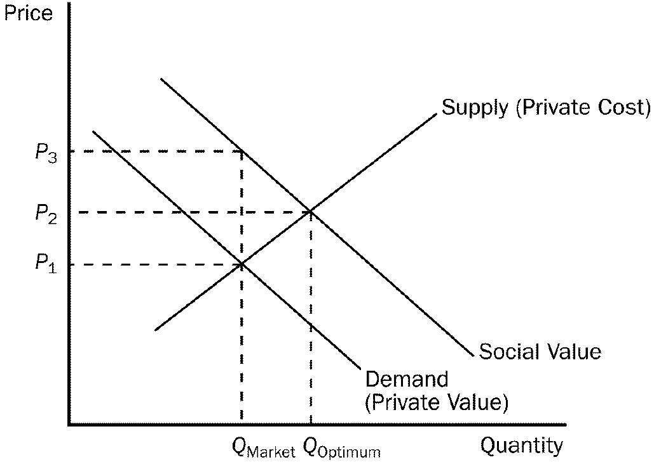
ANS: A positive externality leads the market to exchange a smaller quantity than is socially desirable. The government could help eliminate this inefficiency by subsidizing the product.
SECTION: 1 TYPE: S

3. Using a supply and demand diagram, demonstrate how a negative externality leads to market inefficiency. How might the government help to eliminate this inefficiency?
ANS:

A negative externality leads the market to exchange a larger quantity than is socially desirable. The government could help eliminate this inefficiency by taxing the product.
SECTION: 1 TYPE: S

4. Graphically illustrate the quantity of pollution that would be emitted (a) after a Pigovian tax has been imposed and then (b) after tradable pollution permits have been imposed. Could these two quantities ever be equivalent?
ANS:

Yes, these two quantities could be equal. (For instance, if P^{B} is equal to the amount of the Pigovian tax.)
SECTION:
5. The Coase theorem suggests that efficient solutions to externalities can be arrived at through bargaining. Under what circumstances does this fail to produce a solution?
ANS:

1. The existence of significant transactions costs.
2. Parties may try to hold out for a better deal, and thus the bargaining process breaks down.
3. The number of parties to a bargaining process is large.

SECTION: 2 TYPE: S
6. To produce honey, beekeepers place hives of bees in the fields of farmers. As bees gather nectar, they pollinate the crops in the fields increasing the yields of these fields at no additional cost to the farmer. What might be a reasonable private solution to this externality and how might the solution be reached?
ANS: One solution would be to have the farmer also own the beehives. This internalizes the externality. Another solution would be to have the farmer compensate the owner of the beehives for the value of the pollination. On the other hand, the owner of the beehives prospers by locating his hives next to the farmer's fields. She should be willing to compensate the farmer for this benefit.
SECTION: 2 TYPE: S
7. Why are public policy solutions such as Pigovian taxes and subsidies preferred over regulatory policies?
ANS: The preference for Pigovian taxes and subsidies is based on the ability of markets to signal optimal resource allocation.
SECTION: 3 TYPE: S

